Azure DevOps CI/CD Pipeline for Dockerized Application Deployment on AKS

Objective
Build a complete CI/CD pipeline using Azure DevOps to:
- Build Docker Images
- Push Images to Azure Container Registry (ACR)
- Deploy Applications to Azure Kubernetes Service (AKS)
- Automate application delivery using Azure Pipelines

Step 1: Create Azure Container Registry (ACR)
- Login to Microsoft Azure Portal
- Click Create Resource
- Search Container Registry
- Create:
Setting |  | Value
Resource Group | Azure_AKS
Registry Name | azure1841
SKU | Basic
- Review and Create

Verification
Navigate to:
Resource Group → Container Registry → Repositories
Initially repositories will be empty.

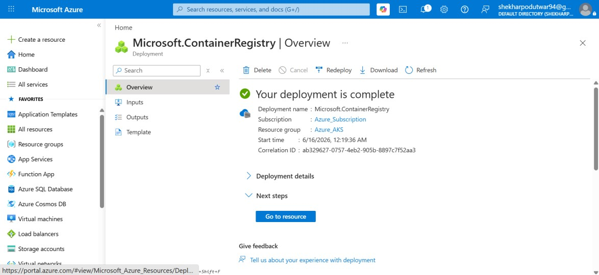

Step 2: Create Azure Kubernetes Service (AKS)
- Go to Azure Portal
- Search for Kubernetes Services
- Click Create
- Select Create Kubernetes Cluster
Provide details:
Setting |  | Value
Resource Group | Azure_AKS
Cluster Name | my-AKS
Region | Central India (or preferred region)
Node Count | 1
Node Size | Standard_B2s
Click Review + Create.

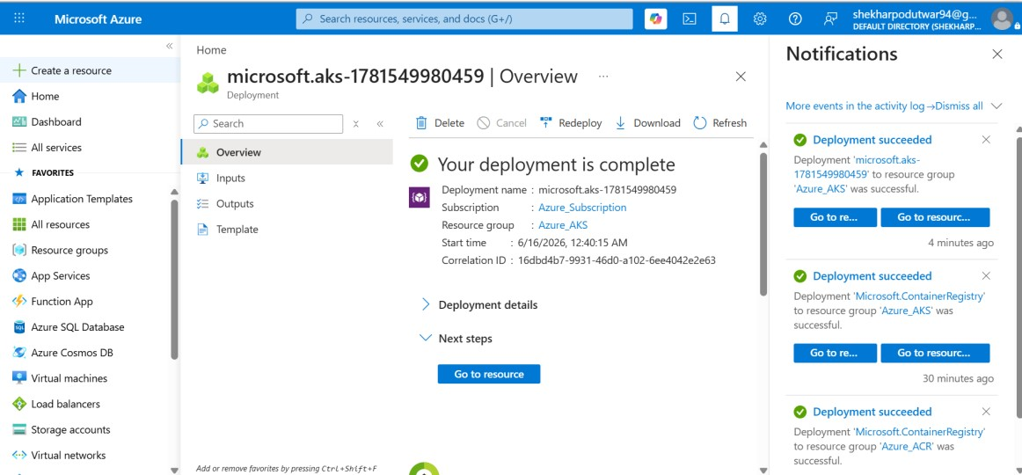
Step 3: Verify Resources
After successful deployment, verify:
- ACR Registry
- AKS Cluster
- Azure Resource Group
Resources should be visible under Resource Group Azure_AKS.
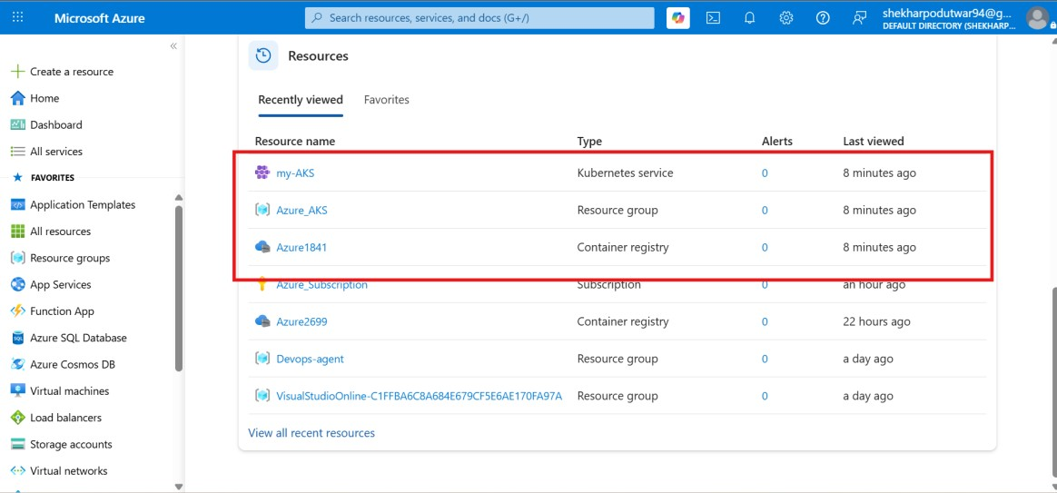
Step 4: Configure Azure DevOps Service Connection
- Open Azure DevOps
- Project Settings
- Service Connections
- New Service Connection
- Select Azure Resource Manager
- Authentication Method: Service Principal (Automatic)
- Save
Example Name:
Azure-Service-Connection

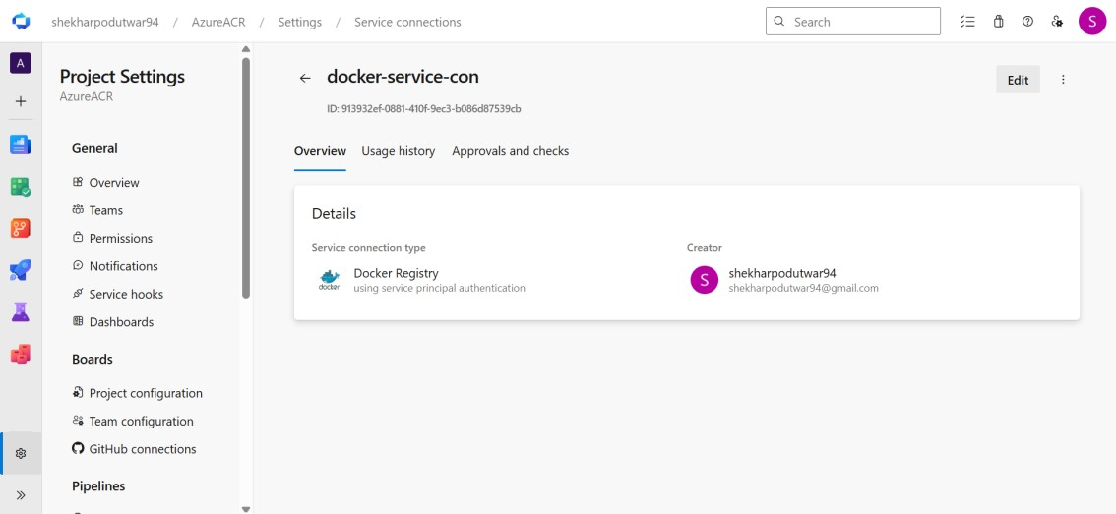
Step 5: Create Azure DevOps Pipeline
- Pipelines
- New Pipeline
- Azure Repos Git
- Select Repository
- Starter Pipeline
Replace YAML with:
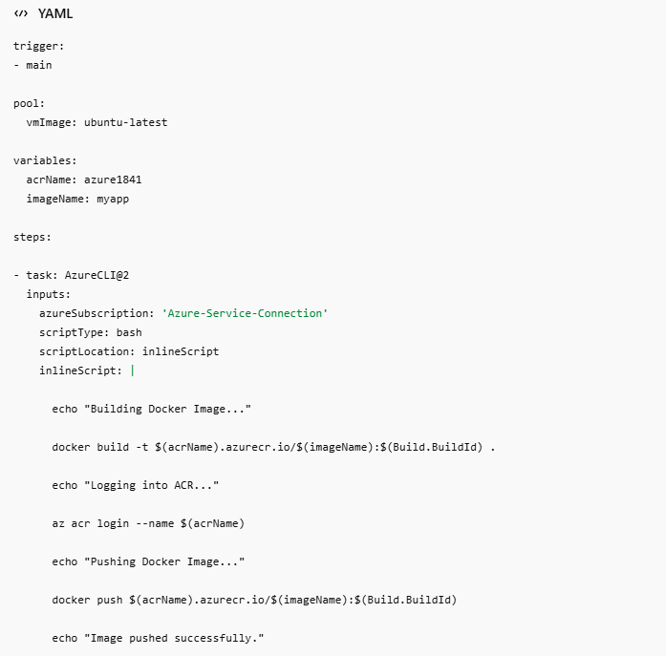
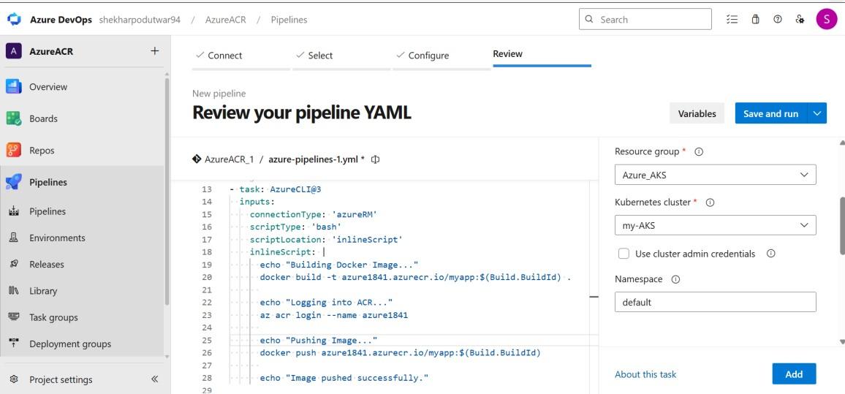
Step 6: Create Kubernetes Manifest Files
deployment.yaml
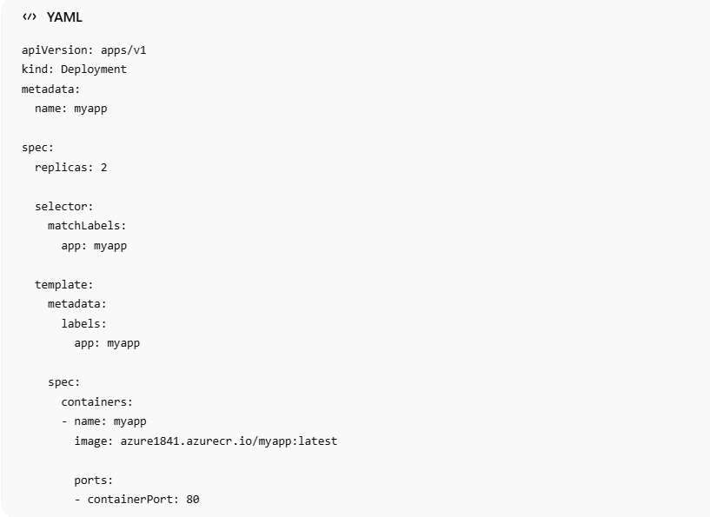
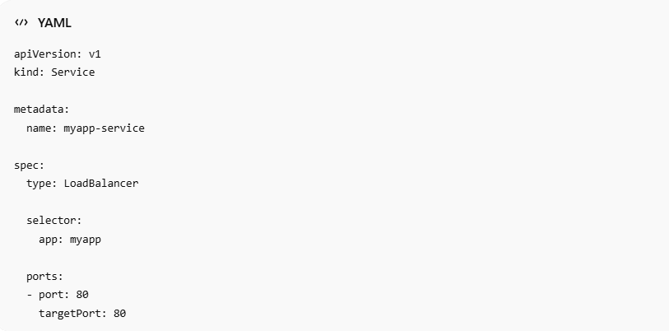
Step 7: Add AKS Deployment Task
Add a Kubernetes task after image push:

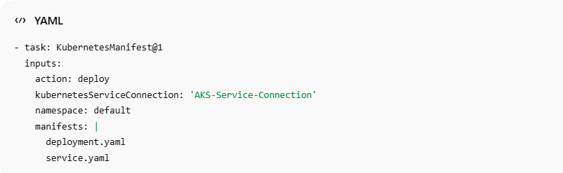
Step 8: Create AKS Service Connection
Azure DevOps:
Project Settings → Service Connections → New Service Connection
Select:
- Kubernetes
- Azure Subscription
- Resource Group: Azure_AKS
- Cluster: my-AKS
- Namespace: default
Save as:
AKS-Service-Connection



Step 9: Run Pipeline
- Save Pipeline
- Commit Code
- Run Pipeline
Pipeline Stages:

